Cross-selling tool
How to use Cross-selling tool to create and manage promotions on your listings

Last Published on 12/05/2011

Table of Contents
Overview 2
Create offers 4
Create related items offers 4
Method # 1: Web form to create related items offers 5
Method # 2: Upload spreadsheet to create related items offers 9
Create order size offers 11
Method # 1: Web form to create order size offers 12
Method # 2: Upload spreadsheet to create order size offers 17
Manage offers 20
Edit order size offers 21
Method # 1: Web form to edit order size offers 21
Method # 2: Upload spreadsheet to edit order size offers 22
Edit related items offers 23
Method # 1: Web form to edit related items offers 23
Method # 2: Upload spreadsheet to edit related items offers 24
Appendix 27
Best practices 27
Important points to note 27
Common errors 30
Helpful links 30

Cross-selling tool

Overview
Online shoppers purchase additional products based on recommendations available on ecommerce websites. According to a study by Forrester Research Inc., 54% of online shoppers noticed recommendations; 77% found to them to be valuable and 34% of those who noticed the recommendations purchased additional products. (Source: North American Technographics® Retail & Customer Service Online Survey Q2 2007)

Cross-sales (encouraging shoppers to add related items to their purchase) were second on the list of top 20 valuable online merchandising features, after keyword search, with 96% of retailers endorsing their value. 95% of online retailers endorsed the value of sales or specials. (Source: Source: the etailing group, '10th Annual Merchant Survey', 12 April 2011)

Welcome to Cross-selling tool. Cross-selling tool gives you the unique opportunity to recommend or cross-sell related products (such as accessories). This allows you to increase order size and revenue - while your buyers enjoy the savings! Cross-selling tool is free - there are no additional costs for you to use this service.

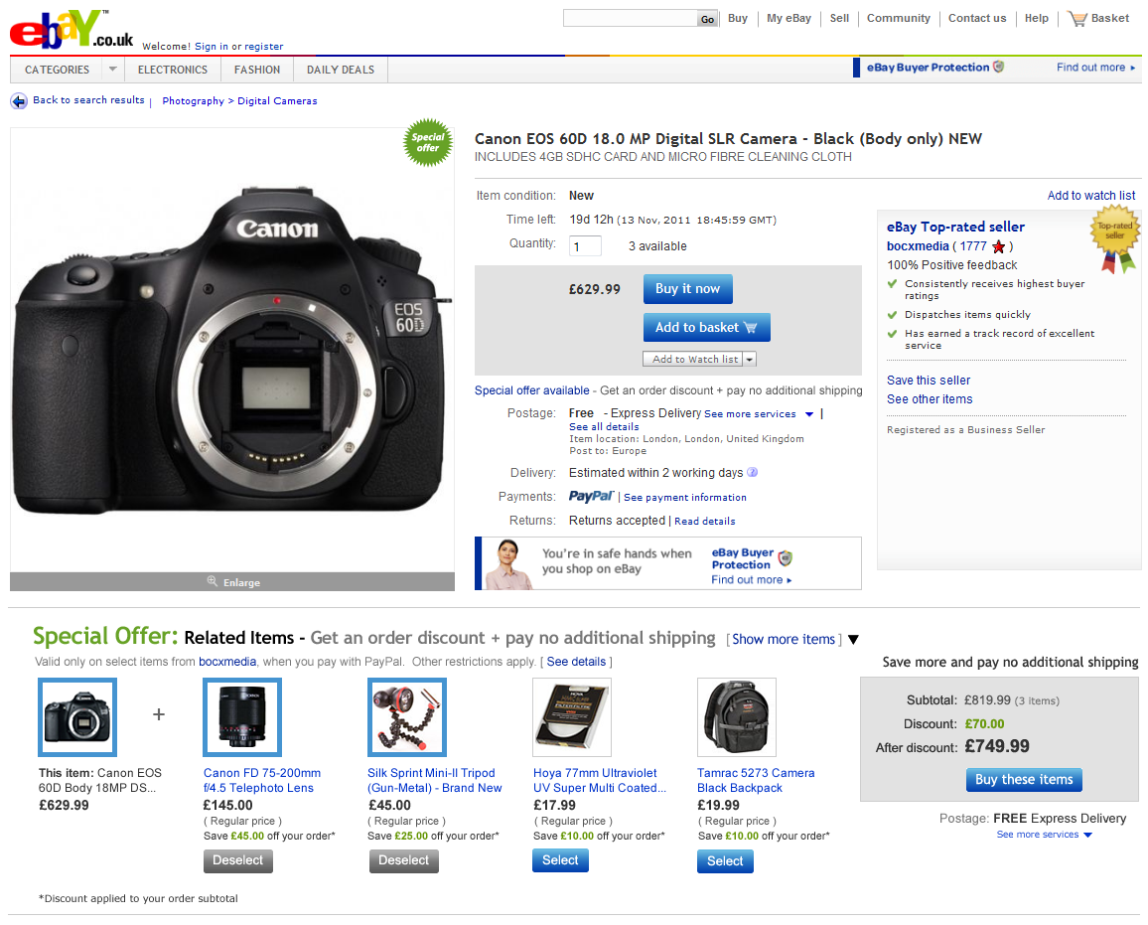 | Cross-selling tool can help buyers:  - Find accessories and related items while they're shopping.  - Lower their delivery costs per item when they buy more.  - Take advantage of special savings from you when they add more items to their order.  Cross-selling tool can help you:  - Increase order size and revenue as buyers purchase more items from you in a transaction.  - Get marketing exposure from cross-selling your related items on your listings.  - Lower delivery costs and increase profit margins by consolidating bundled orders.  Cross-selling tool is currently in CLOSED BETA - but due to demand from sellers who want to prepare for the holiday season, we're opening it up to select sellers right now.
This document provides step-by-step instructions on how to create related items and order size offers for your listings.

Before you get started…

- Seller requirements:

  - Use SKU numbers to create more targeted offers. The SKU number must be located in the 'Custom Label' field of your listing. If you don't currently use this field, you can add or edit it in Selling Manager, Selling Manager Pro, Turbo Lister, the bulk edit and revise tool in My eBay, File Exchange and through the API. Learn more about these eBay selling tools.
  - Sellers must set the 'Offer combined payments and postage' preference to 'Yes' in My eBay - Site preferences - Postage and packaging preferences in order to support offers. This is the default setting.
  - The primary item in a related items offer can carry a P&P cost. However, all related items must offer free P&P as one of the delivery options. Make sure you offer the same class of service on the primary item as the related item's service that has free P&P to consolidate bundled purchases into one order, so you can send the order in one box and reduce your postage costs. For example, a buyer purchases a camera that offers standard delivery for £5 and additional related items that offer standard delivery for free. When the buyer completes the purchase, all items will be consolidated into a single order with a total P&P cost of £5 for standard delivery.
  - If you are integrating directly with the eBay API use eBay's GetOrders API (not GetTransactions API) to consolidate bundled purchases into one order, so you can send the order in one box and reduce your postage costs.

- Current limitations:

  - Offers can only be configured for fixed price listings or auction-style listings with a Buy It Now price available on eBay.com or eBay.co.uk.
  - All listings included in an offer must offer PayPal as one of the payment options.
  - Multi-variation listings (such as a shirt that comes in multiple colours and sizes) are currently not supported by Cross-selling tool.
  - Listings which use the 'see price at checkout' feature are currently not supported by Cross-selling tool.

Step 1: Make sure your account manager has whitelisted you.
Go to: http://cgi1.ebay.co.uk/ws/eBayISAPI.dll?ConfiguratorAccept
Sign in with your eBay user ID and password.

Create offers

There are two types of offers you can create for your listings
- Order size - Provide general discounts to buyers on their entire order when they meet your purchase requirements.
Example offers:
  - Save £10 when you spend £100 or more.
  - Save 20% when you spend £100 or more.
  - Buy 3 items for the price of 2 (value of lowest-priced item(s) will be deducted from the order subtotal)
  - Buy 2 or more items, get 50% off 1 of the items in your order (discount value of lowest-priced item(s) will be deducted from the order subtotal)
- Related items - Cross-sell additional related items (such as accessories) when buyers purchase a qualified primary item.
Example offers:
  - Get 10% off select accessories with the purchase of any of these cameras.
  - Get £25 off a Blu-ray player with the purchase of this TV.
  - Buy ink cartridges with your printer at no extra P&P cost.
Important: Cross-selling tool currently does not support global offers. If you list products on the other international eBay sites, you will have to configure offers on those sites separately. If you have a listing on eBay.com/.co.uk that offers worldwide delivery, buyers will only see your configured offer if they browse the respective eBay site even though your listing is also surfaced on eBay's international sites.

Create related items offers
- Go to: http://cgi1.ebay.co.uk/ws/eBayISAPI.dll?ConfiguratorAccept and sign in with your eBay user ID and password.  - You will land on the Cross-selling tool dashboard. (See figure A)  - There are two ways to create your related items offer  - Web form (create one offer at a time)  - Click on the Create related items offer button. (See figure A-1)  - Excel spreadsheet (upload offers in bulk)  - Click on the Upload related items offers link. (See figure A-2)  Tip: We recommend you create your first few offers using the web form. Once you've mastered the process, you can use an Excel spreadsheet for bulk uploading subsequent offers. | Figure A  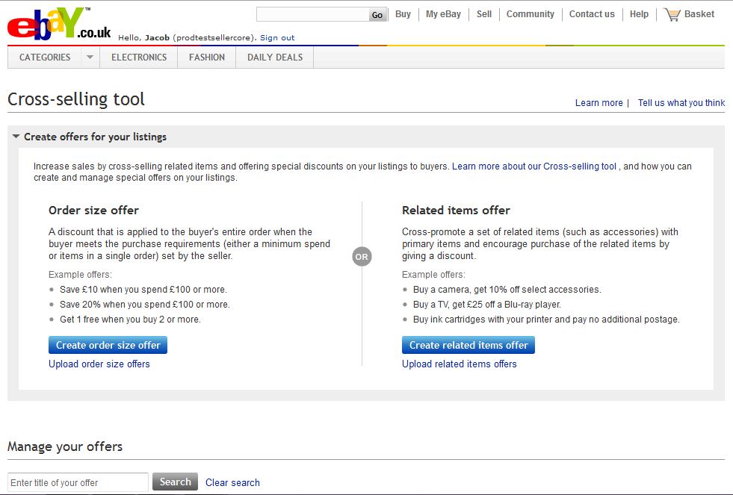  1  2

Method # 1: Web form to create related items offers
After you click on the Create related items offer button from the dashboard, you will land on the Create a new related items offer page. (See figure B)  Step 1:  - Start by entering a primary SKU into the text box. This primary SKU is the parent SKU. If, for example, you are configuring an offer for a camera with a tripod, camera case, lens and batteries, the camera is the primary SKU and the others are the related items. You will identify the related items in the next step of the process.  - There are two ways to enter a primary SKU:  - Enter it directly into the text box on the Create a new related items offer page. SKUs are NOT case sensitive; they will be converted to upper case automatically. (See figure B-1)  - Click on Look it up to search for the SKU you want. (See figure B-2)  - Once you find the SKU you are looking for, highlight it, and then click Select. (See figure C)  - Your primary SKU will be entered into the text box.  - Click Continue. (See figure B-3) | Figure B  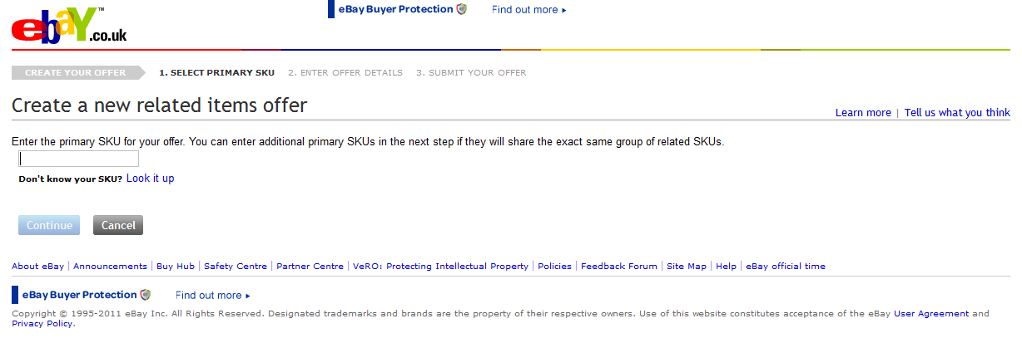  1  2  3  Figure C  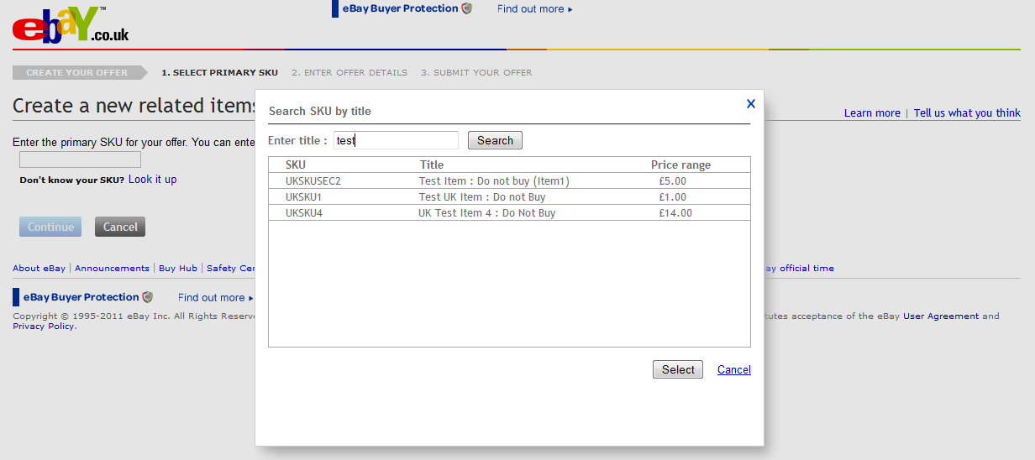
Step 2:  - You will now be on step 2 - Enter offer details. (See figure D)  - To add more primary SKUs, click on Add More SKUs under the Select primary SKUs section. This allows you to relate the same set of related items to multiple primary SKUs. (See figure D-1)  - Complete the following fields under the Select related SKUs section (See figure D-2):  - Group title - Group titles are not visible to buyers. A group is a way you can organise related SKUs if they are variations of the same type of item. For example, you could create a group for tripods and include several different types of tripods in that group with the title 'Tripods'. Then you could create a group for camera bags, and include several different bags in that group with the title 'Camera bags'.  - SKU - Enter the SKU of your first related item. Similar to how you entered the primary SKUs, you can enter a SKU into the text box or look up the related item using the Look up SKU link.  - Discount (optional) - Enter an amount or percent discount value that will only be applied when the buyer purchases this related SKU with the primary item. Note that the discount will be applied to the buyer's order subtotal and then itemised across all items (primary and related) applicable to the offer on a cost-weighted basis.  Example 1: Discount of £50 if you buy a camera (normal price: £900) together with a camera bag (normal price £100)  Normal undiscounted prices in the order:  Camera: £900  Bag: £100  Undiscounted subtotal: £1,000  Total discount: £50  Equivalent order discount in percentage terms: 5% (£50 off £1,000)  5% discount applied to items in the order:  Camera: £900 minus 5% = £855  Bag: £100 minus 5% = £95  - Quantity (optional) - Enter the maximum quantity of the related item that can be purchased with discount for every primary item bought. Buyers who choose to purchase additional quantities beyond your limit will buy them at the regular listed price.  - You can add up to 14 related SKUs to a group by clicking Add more SKUs. (See figure D-3)  - Complete the following mandatory fields under the Schedule your offer section (See figure D-4):  - Offer title - Offer titles are not visible to buyers. They simply help you track the offers you've created. You may wish to copy and paste the primary SKU number into this field.  - Start date - Date you want the offer to become active and visible to buyers on eBay. Offers will start at 00.01am (midnight) GMT/BST of the date you choose unless you choose today's date in which case the offer will start immediately.  - End date - Date you want the offer to be de-activated. Offers will end at 11.59pm GMT/BST of the date you choose.  Note: The top 4 related items will be displayed on the listing page of the primary item(s) by default (See figure E). Buyers will need to click on the Show All link to expand the module on the listing page to see the remaining 14 related items. Cross-selling tool will use an algorithm based on item price, P&P cost and quantity sold to determine the order in which your configured related items are displayed. If your related items are new and do not have sales history on eBay, Cross-selling tool will use the order in which you provided the related SKUs to determine the display position.  - Click Submit on the bottom of the page when you are done.  - You will be redirected back to the dashboard. It may take up to a minute for your offer to appear under the Manage your offers section. (See figure F)  Note: Once your offer has been submitted it will appear as Scheduled. If you schedule your offer on the same day as the Start date, your offer will automatically move to Active status after 5-10 minutes. Related items offers are NOT live on eBay and visible to buyers on the Item page until they show up as Active. | Figure D  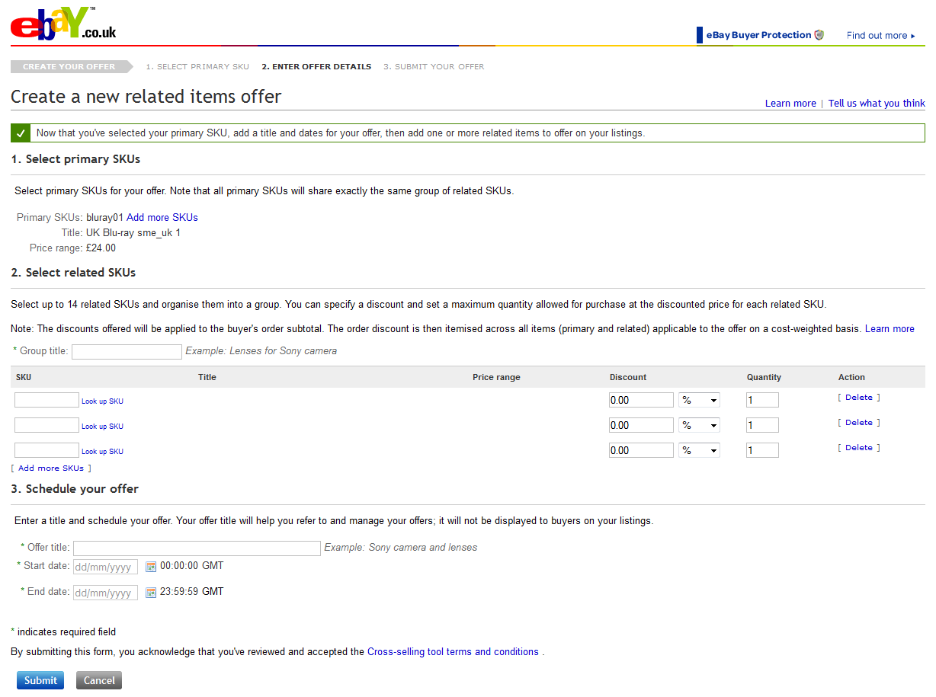  1  2  3  4  Figure E  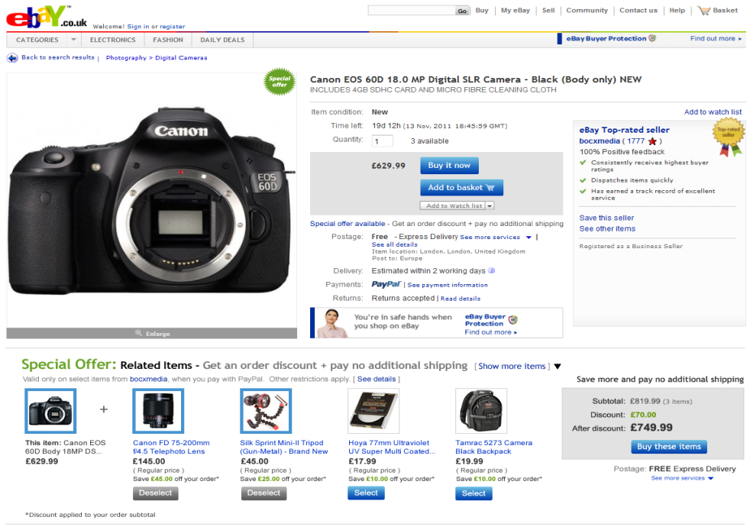  Figure F  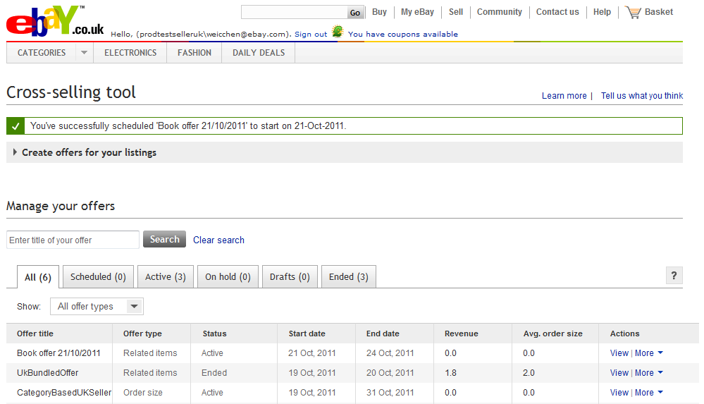

Method # 2: Upload spreadsheet to create related items offers
After you click on the Upload related items offers link from the dashboard, you will land on the Upload/edit your related items offers page. (See figure G)  Step 1:  - Download a blank spreadsheet by clicking Download (.csv) template. (See figure G) | Figure G  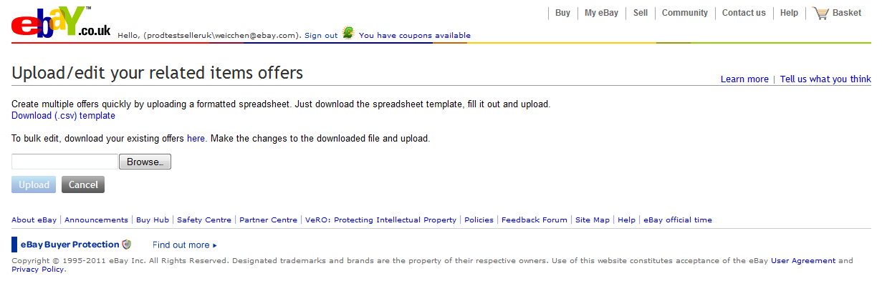
Step 2:  - Open up the .csv template you saved and complete the following fields (See figure H):  - Offer ID - Leave this blank. The system will automatically generate an Offer ID for you when you create a new offer.  - Offer title - Offer titles are not visible to buyers. They simply help you track the offers you've created. You may wish to copy and paste the primary SKU number in this field.  - Start date - Date you want the offer to become active and visible to buyers on eBay. Enter in the format of DD/MM/YYYY or DD/MM/YYYY HH:mm. If you enter a date in the format of DD/MM/YYYY then the offer will start at 00.01am (midnight) GMT/BST of the date you choose unless you choose today's date in which case the offer will start immediately.  - End date - Date you want the offer to be de-activated. Enter in the format of DD/MM/YYYY or DD/MM/YYYY HH:mm. If you enter a date in the format of DD/MM/YYYY then the offer will end at 00.01am (midnight) GMT/BST of the date you choose.  - Action - Type CREATE in this field. You only need to type this once for each separate offer.  - Status - Leave blank (this will only be used when modifying an offer)  - Primary SKUs - Enter the SKU number of the primary items of the offer (SKUs are NOT case sensitive). Separate each SKU using a comma. This allows you to relate the same set of related items to multiple primary SKUs.  - Group title - Enter a title for your group of related items. Group titles are not visible to buyers on the listing page. For example, if you are cross-selling tripods, camera bags and lenses with your camera, you can submit multiple tripod SKUs under the 'Tripods' group, multiple camera bags under the 'Camera bags' group and so on.  - Related SKU - These are the SKU numbers for the related items. Put one SKU number in each row you would like to associate with a group.  - Discount type - Specify whether discount is a percentage or an amount off the price of a related SKU. Enter Percentage for percentage off, Amount for amount off.  - Discount value - Specify the percentage off or the amount off the price of the related item. Discounts offered will be applied to the buyer's order subtotal. The order discount is then itemised across all eligible items on a cost-weighted basis.  - Currency code - Specify the currency in which you sell on eBay. For UK sellers, it generally will be GBP. You only need to include this for 'Amount' discounts.  - Discount quantity limit - Enter the maximum quantity of the related item that can be purchased with discount for every primary item bought. Buyers who choose to purchase additional quantities beyond your limit will buy them at the regular listed price.  Once you have filled out your spreadsheet, save it to your computer in .csv (Comma delimited) format.  Step 3:  - Click Browse on the Upload/edit your related items offers page. Search for your saved spreadsheet and click Open to select the file for upload. (See figure G)  Note: You can upload up to 1,000 offers in a spreadsheet at a time. Each offer can have up to 500 primary SKUs with up to 14 related SKUs.  - Click Upload. (See figure G)  - You will now see the number of offers created successfully. You will see how many failed (if any), and the associated error. (See figure I)  Tip: See the Common Errors section in the Appendix for common errors and possible solutions.  Note: You can keep track of the SKUs you've uploaded by downloading a spreadsheet of your existing related items offers (explained in the Manage offers section). This will help prevent you from uploading duplicate SKUs at a later time. | Figure H  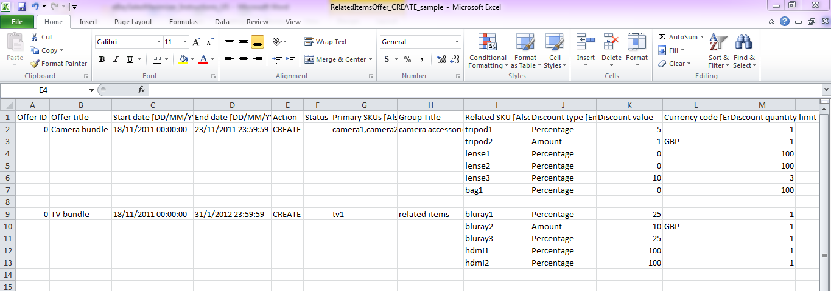  Figure I  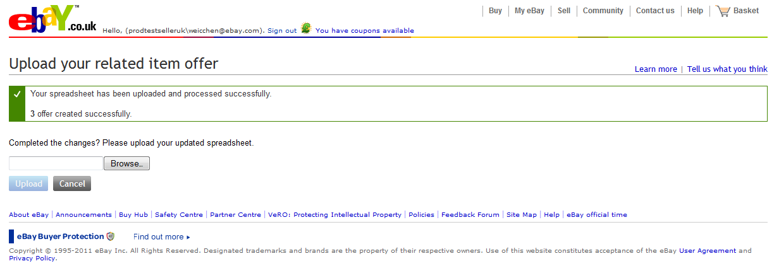

Create order size offers
- Go to: http://cgi1.ebay.co.uk/ws/eBayISAPI.dll?ConfiguratorAccept and sign in with your eBay ID and password.  - You will land on the dashboard. (See figure A)  - There are two ways to create your order size offer  - Web form (create one offer at a time)  - Click on the Create order size offer button. (See figure A-1)  - Excel spreadsheet (upload offers in bulk)  - Click on the Upload order size offers link. (See figure A-2)  Tip: We recommend you create your first few offers using the web form. Once you've mastered the process, you can use an Excel spreadsheet for bulk uploading subsequent offers. | Figure A  1  2

Method # 1: Web form to create order size offers
After you click on the Create order size offer button from the dashboard, you will land on the Create special offers for your listings page. (See figure B)  Step 1:  - Start by filling out the discount information under the Create a new offer section.  - Choose a purchase requirement for the discount:  - Minimum order (See figure B)  - Select a minimum purchase amount from the drop-down menu or specify your own value when you select other. Enter a whole number.  - Choose a discount type  - Purchase discount  Select a discount amount from the drop-down menu or specify your own value when you select other. Enter a whole number.  - Percentage discount  Select a discount from the drop-down menu.  - Minimum quantity (See figure C)  - Select a minimum purchase quantity from the drop-down menu. This quantity should include any free items you are providing as a part of the offer.  - Choose a discount type  - Purchase discount  Select a discount amount from the drop-down menu or specify your own value when you select other. Enter a whole number.  - Percentage discount  Select a discount from the drop-down menu.  - Item discount (e.g. “Get 2 items for the price of 1”)  Select a quantity and discount from the drop-down menus. The lowest-priced qualifying item(s) will be | Figure B  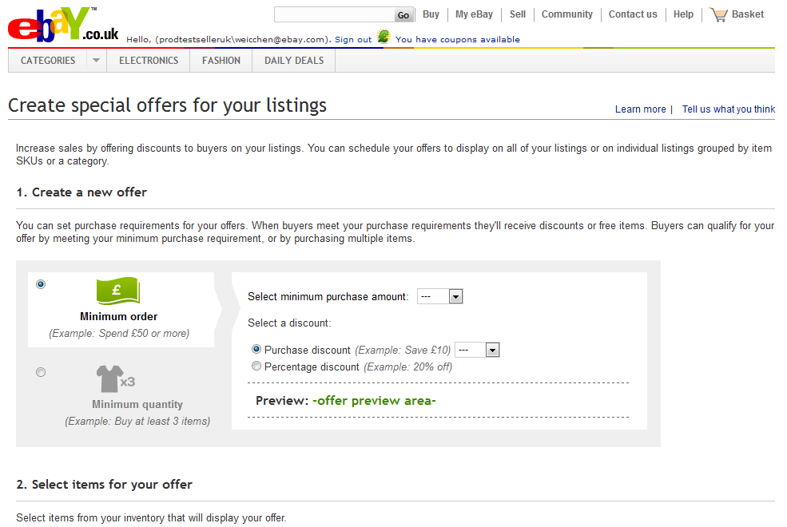  Figure C  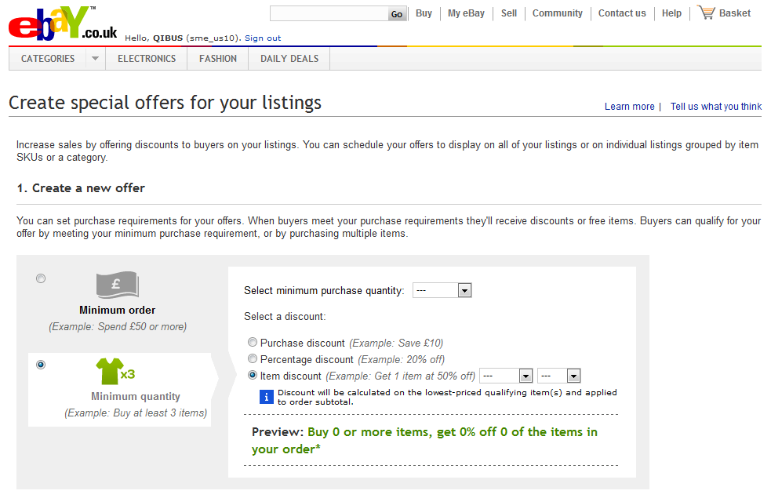
discounted from the subtotal amount of the order.  Step 2:  - Choose an option under the Select items for your offer section:  - All inventory (See figure D)  With this option, all your items listed on eBay will be eligible for this discount.  Note: Remember even a single item that meets the purchase requirements for your offer can receive the discount.  - Only items from a selected category (See figure E)  With this option, all your items listed in a chosen eBay category will be eligible for this discount.  - Click on Select a category.  - Highlight a category of your choice (See figure F)  - Click on Select this category.  Note: Remember even a single item that meets the purchase requirements for your offer can receive the discount. | Figure D  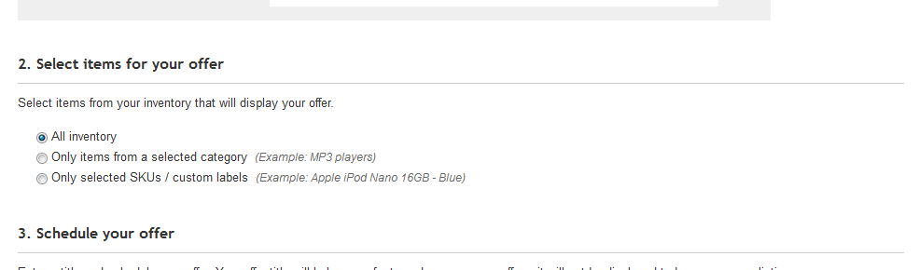  Figure E  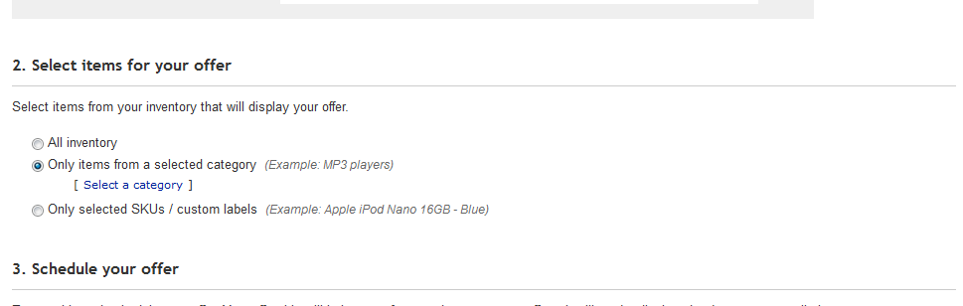  Figure F  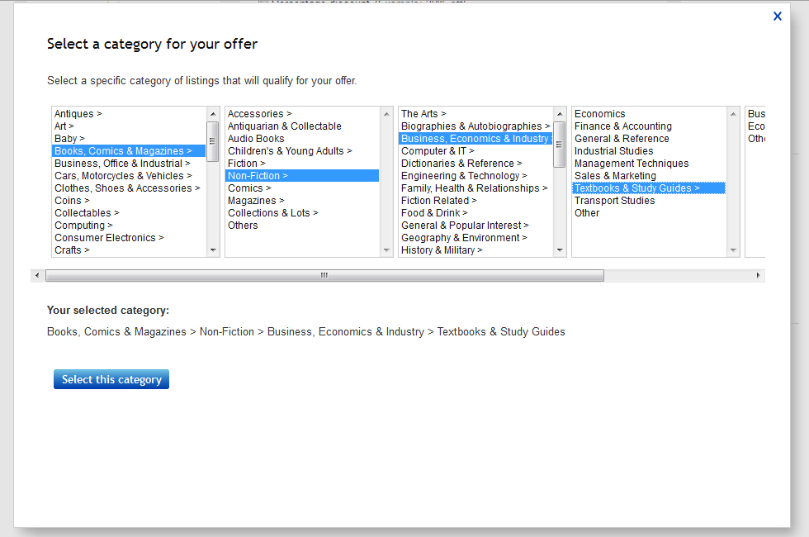
- Only selected SKUs / custom labels (See figure H)  With this option, all items listed with this SKU number will be eligible for this discount.  - Click on Enter SKUs if you know the SKUs you want.  - Click on Add these SKUs when you are done. (See figure I)  - Click on Select individual SKUs if you want to look up the SKUs from your current listings by eBay category.  - Highlight the category you want to search in and click on View SKUs in this category to proceed. (See figure J)  - You may further refine your search results.  - Choose your SKU numbers.  - Click Add selected SKUs when you are done. (See figure K)  - You may enter or select up to 25 SKUs total. | Figure H  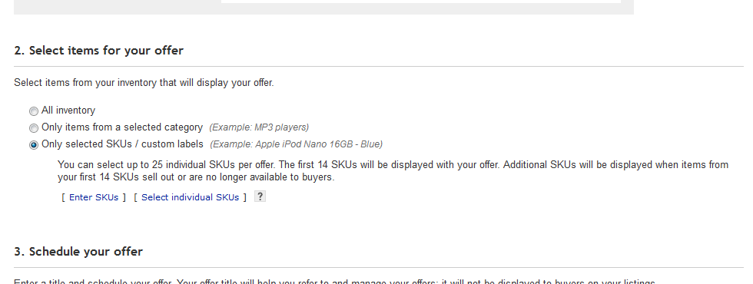  Figure I  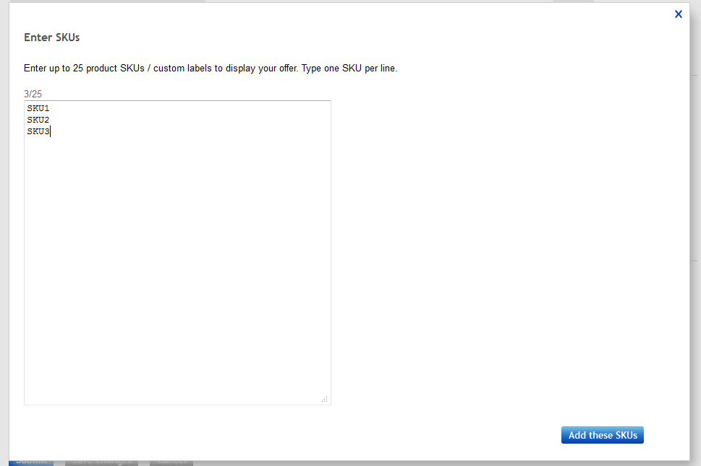  Figure J  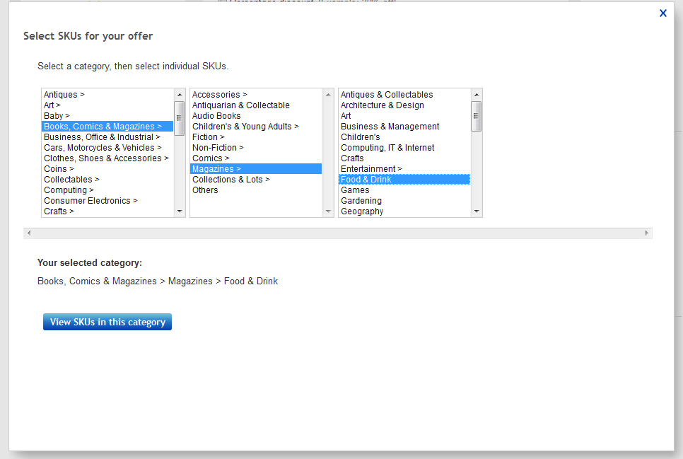
Note: The top 4 items will be displayed on the listing page of any of the eligible items by default (See figure L). Buyers will need to click on the Show All link to expand the module on the listing page to see the remaining top 10 eligible items. Cross-selling tool will use an algorithm based on item price, P&P cost and quantity sold to determine the order in which your configured items are displayed. If your items are new and do not have sales history on eBay, Cross-selling tool will use the order in which you provided the SKUs to determine the display position. | Figure K  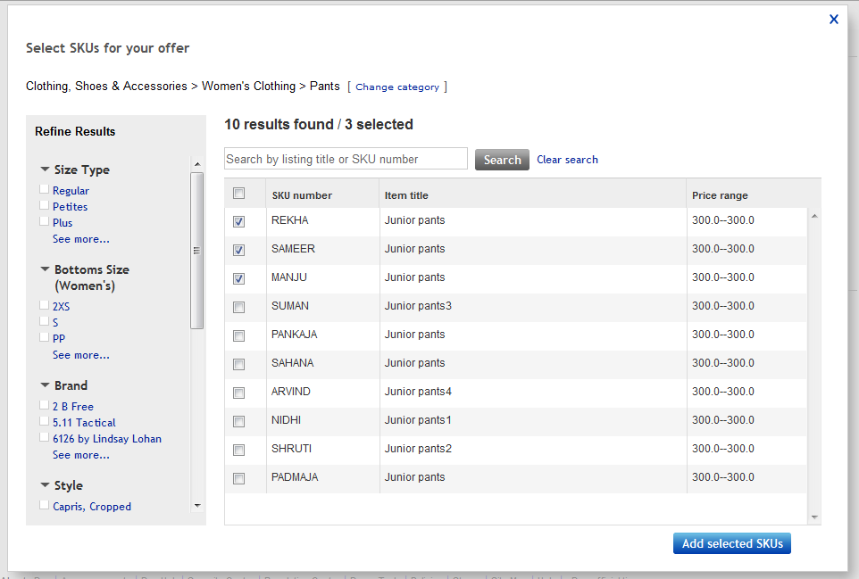  Figure L  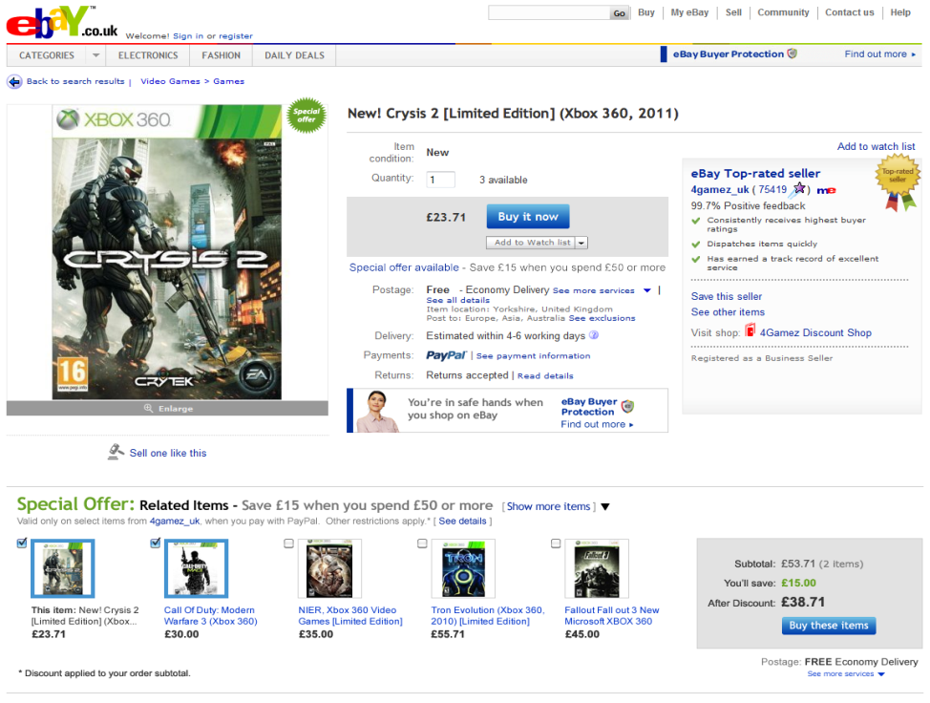
Step 3:  - Complete the following mandatory fields under the Schedule your offer section (See figure M):  - Offer title - Offer titles are not visible to buyers. They simply help you track the offers you've created.  - Start date - Date you want the offer to become active and visible to buyers on eBay. Offers will start at 00.01am (midnight) GMT/BST of the date you choose unless you choose today's date in which case the offer will start immediately.  - End date - Date you want the offer to be de-activated. Offers will end at 11.59pm GMT/BST of the date you choose.  - Click Submit to schedule your offer.  OR  Click Save changes to save your offer as a draft for now.  Note: Offers in Draft status will not be live on eBay and visible to buyers on the scheduled start date. You must first edit the offer with the final revisions you want and submit the offer to change the status to Scheduled (explained in the Manage Offers section).  - You will be redirected back to the dashboard once you've created the offer. | Figure M  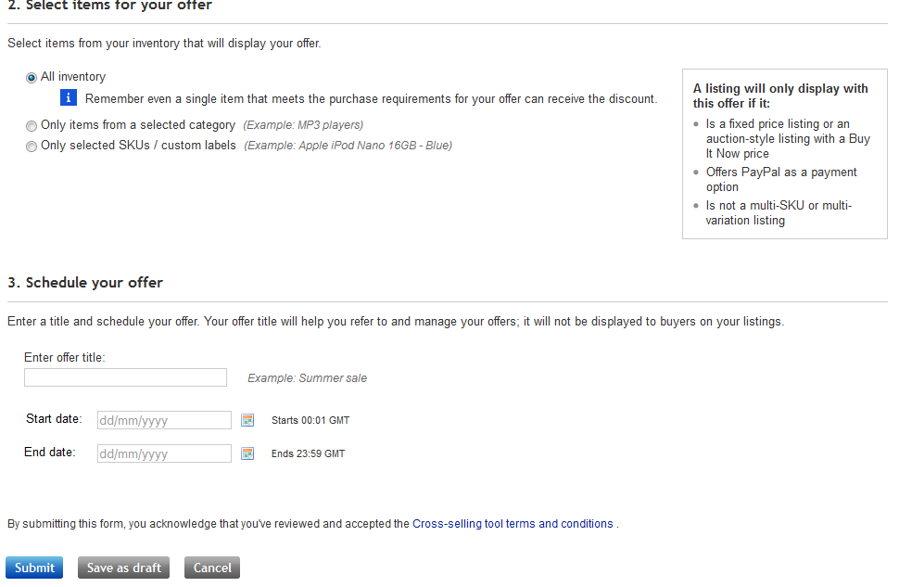

Method # 2: Upload spreadsheet to create order size offers
After you click on the Upload order size offers link from the dashboard, you will land on the Upload your offers page. (See figure N)  Step 1:  - Download a blank spreadsheet by clicking Download .csv template. (See figure N-1)  - Next, choose either to provide different start and end dates for all the offers or the same start and end dates for all the offers under the Upload your file section. (See figure N-2)  Step 2:  - Open up the .csv template you saved and complete the following fields (See figure O):  - Offer title - Offer titles are not visible to buyers. They simply help you track the offers you've created. Note you can only enter a maximum of 30 characters.  - Start date - Date you want the offer to become active and visible to buyers on eBay. Enter in the format of DD/MM/YYYY. Offers will start at 00.01am (midnight) GMT/BST of the date you choose unless you choose today's date in which case the offer will start immediately. Leave this field blank if you had chosen to provide the same date for all offers on the Upload your offers page.  - End date - Date you want the offer to be de-activated. Enter in the format of DD/MM/YYYY. Offers will end at 11.59pm GMT/BST of the date you choose. Leave this field blank if you had chosen to provide the same date for all offers on the Upload your offers page.  - Purchase requirement - Specify the type of purchase requirement to be eligible for your offer. Enter SPEND for minimum spend or VOLUME for minimum quantity. | Figure N  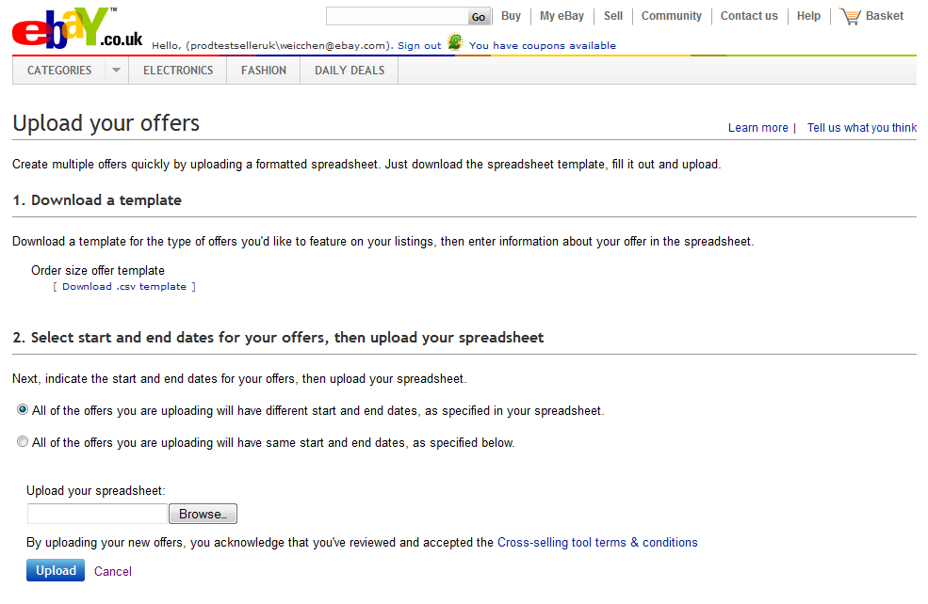  1  2  Figure O  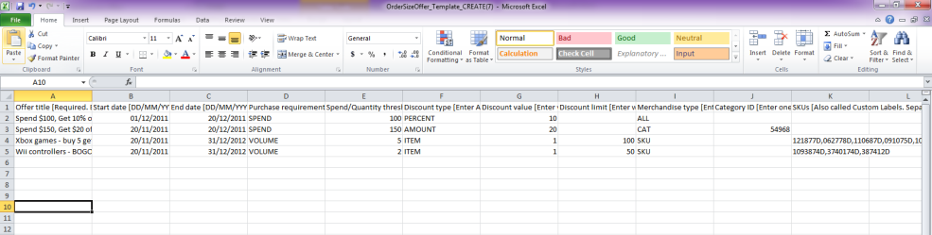
- Spend/Quantity threshold - Enter the minimum purchase amount or quantity required to get the discount. The quantity you provide should include any free items with your offer. Please enter a whole number.
- Discount type - Specify whether discount is a percentage off/an amount off the entire order, or get free item(s) with purchase. Enter PERCENT for percentage off, AMOUNT for amount off or ITEM for free items with purchase.
- Discount value - Enter the percentage, the amount or the quantity value off the entire order. Discount is calculated based on the regular price of all eligible items within an order before P&P and other fees, and applied to the entire order.
- Discount limit - Only used for ITEM discount at this time. Enter the percentage off the number of lowest priced item(s) specified in the “Discount value” column. Entering 100 means the lowest priced item(s) will be free.
- Merchandise type - Specify whether the discount will be applicable to all of your listings or on individual listings grouped by item SKUs or a category. Enter ALL for all your listings, CAT for only items from a selected category or SKU for only items with selected SKUs.
- Category ID - Enter a single eBay category ID of your choice.
- SKUs - Enter the SKU number of the items eligible for discount (SKUs are NOT case sensitive). Separate each SKU number using comma. You may list up to 25 SKUs.

- Once you have filled out your spreadsheet, save it to your computer in .csv (Comma delimited) format.

Step 3:  - Click Browse on the Upload your offers page. Search for your saved spreadsheet and click Open to select the file for upload. (See figure P-1)  Note: You can upload up to 500 offers each with 25 SKUs maximum at a time.  - Click Upload. (See figure P-2)  - You will be redirected to the dashboard if all offers are created successfully.  - Otherwise, you will receive a confirmation of how many offers were created successfully and how many offers had failed. (See figure Q)  - Download an error report with the offers that failed to your computer. The data you had entered will be preserved in the error report with an additional column to the very right containing all the errors encountered for each order size offer.  - Fix the errors in this spreadsheet and save your changes.  - Click Browse to search for the fixed error report on your computer  - Click Upload when finished.  Tip: See the Common Errors section in the Appendix for common errors and possible solutions.  Note: You can keep track of the SKUs you've uploaded by downloading a spreadsheet of your existing order size offers (explained in the Manage offers section). This will help prevent you from uploading duplicate SKUs at a later time. | Figure P  1  2  Figure Q  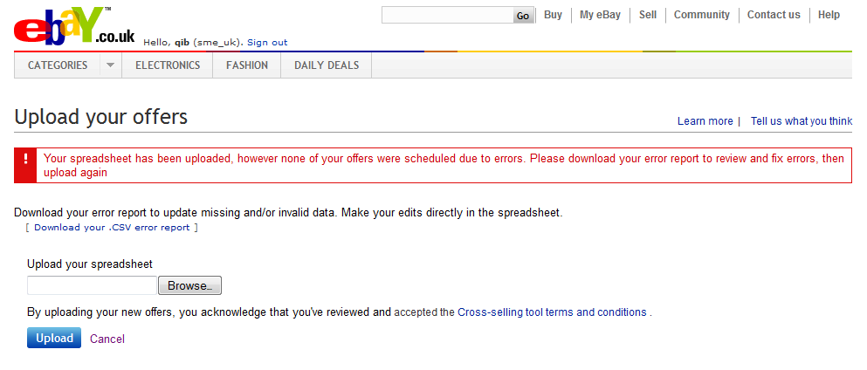

Manage offers

- Go to: http://cgi1.ebay.co.uk/ws/eBayISAPI.dll?ConfiguratorAccept and sign in with your eBay ID and password.  - You will land on the Cross-selling tool dashboard. (See figure A)  - From the dashboard you can see a summary view of all your offers. (See figure A-1)  - Click on the help bubble to see a definition of certain columns in the table. (See figure A-2)  - Click on a column header to sort your offers by that field.  - Click on View under the Actions column to see an offer's detail. You have the option to take action on the offer from here or return to the dashboard.  - Use the More drop-down menu under the Actions column to edit, copy, delete, put on hold or resume an offer. Note the options will vary depending on the status of the offer. (See figure A-3)  Note: Placing an offer on hold or resuming an offer will take effect immediately. | Figure A  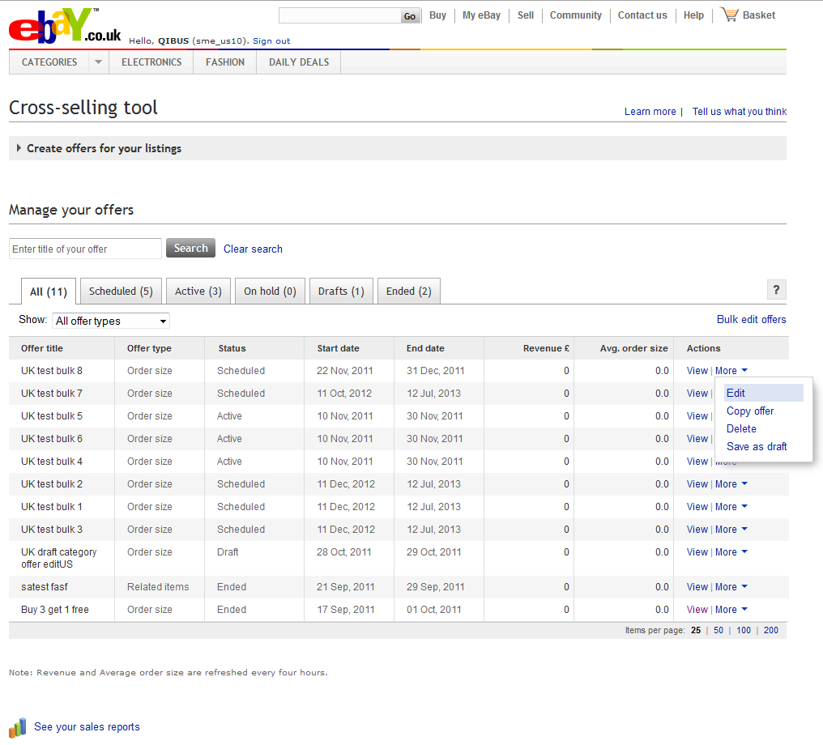  1  2  4  3  4  4

Edit order size offers
- There are two ways to edit your order size offer  - Web form (edit one offer at a time)  - Click on Edit from the More drop-down menu on the dashboard to edit your offer. (See figure A-3)  - You will be redirected to the Edit your offer page. (See figure B)  - Excel spreadsheet (edit offers in bulk)  - Click on the Bulk edit offers link. (See figure A-4)  Tip: We recommend you edit your first few offers using the web form. Once you’ve mastered the process, you can use an Excel spreadsheet for bulk editing subsequent offers. | Figure B  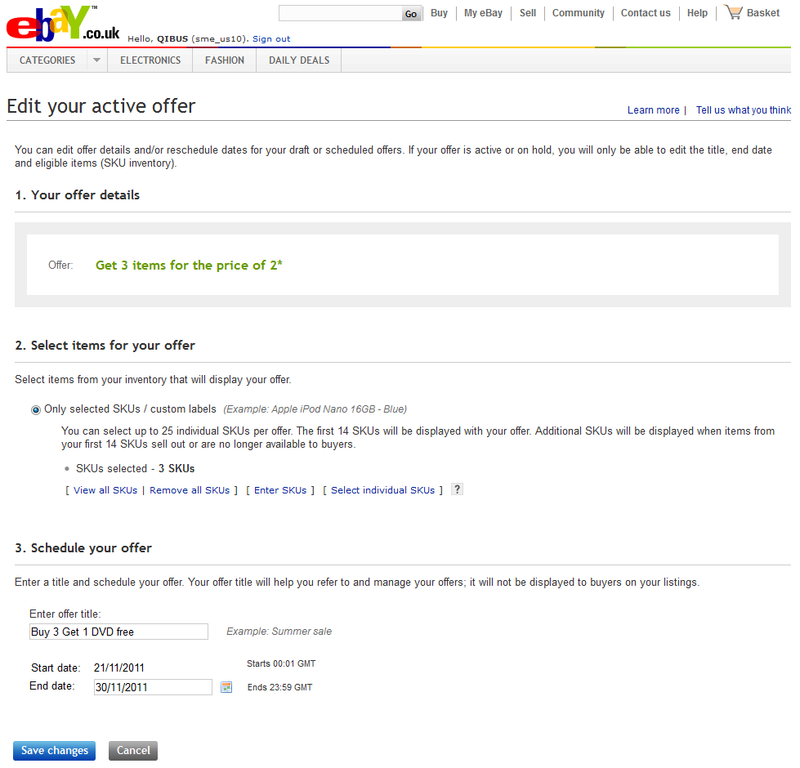

Method # 1: Web form to edit order size offers
- You may edit any field on offers in Draft or Scheduled status.

- Once an offer is Active or On Hold, the only edits allowed are:
  - Modifying the Offer title (See figure B-1)
  - Modifying the End date (See figure B-2)
  - Adding or removing Selected SKUs if the offer was a SKU based offer to begin with (See figure B-3)

Certain edits you make to an Active or On Hold offer may take up to 15 minutes to be reflected on the live eBay site.

Method # 2: Upload spreadsheet to edit order size offers
- After you click on the Bulk edit offers link from the Cross-selling tool dashboard, you will land on the Bulk edit your offers page. (See figure C)  - Click on the Download .csv template link under the “Order size offer template” option to download all your existing order size offers into a .csv file. (See figure C-1)  - Open the .csv file you just downloaded and make edits directly within this spreadsheet. (See figure D)  - Remove any offers you do not plan to edit by deleting the entire row. This will make it easier for you to manage your spreadsheet.  - Do not modify the Offer ID (column A).  - You may edit any field on offers in Draft or Scheduled status.  - Once an offer is Active or On Hold, the only edits allowed are:  - Modifying the Offer title (column B)  - Modifying the End date (column D)  - Changing Status from Active to On Hold or vice versa (column E)  - Adding or removing SKUs if the offer was a SKU based offer to begin with (column M)  - Save the file on your computer.  - Click Browse on the Bulk edit your offers page. Search for your saved spreadsheet and click Open to select the file for upload. (See figure C-2)  - Click Upload. (See figure C-3)  Tip: See the Common Errors section in the Appendix for common errors and possible solutions. | Figure C  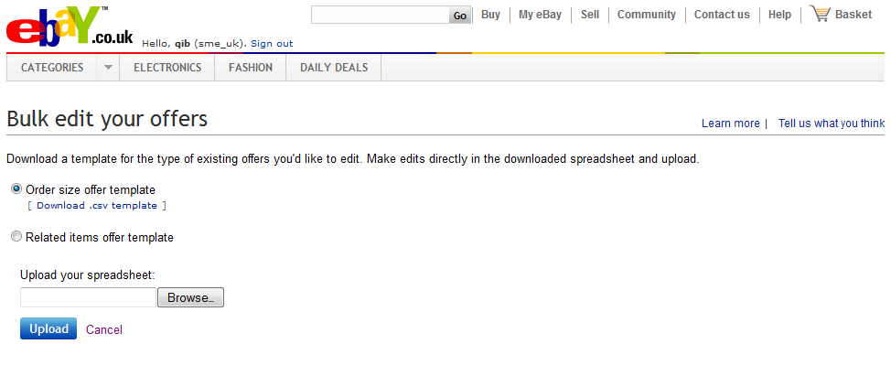  1  2  3  Figure D  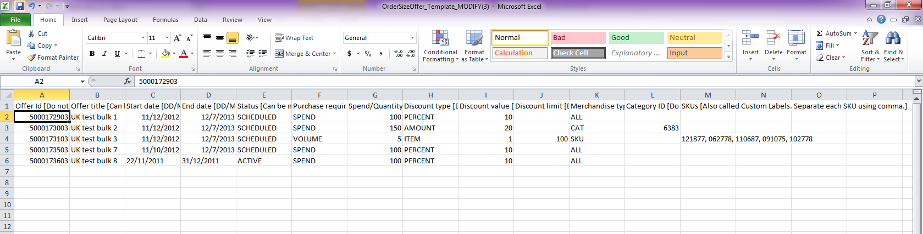

Edit related items offers
- There are two ways to edit your related items offer  - Web form (edit one offer at a time)  - Click on Edit from the More drop-down menu on the dashboard to edit your offer. (See figure A-3)  - You will be redirected to the Edit your offer page. (See figure  E)  - Excel spreadsheet (edit offers in bulk)  - Click on the Bulk edit offers link. (See figure A-4)  Tip: We recommend you edit your first few offers using the web form. Once you’ve mastered the process, you can use an Excel spreadsheet for bulk editing subsequent offers. | Figure E  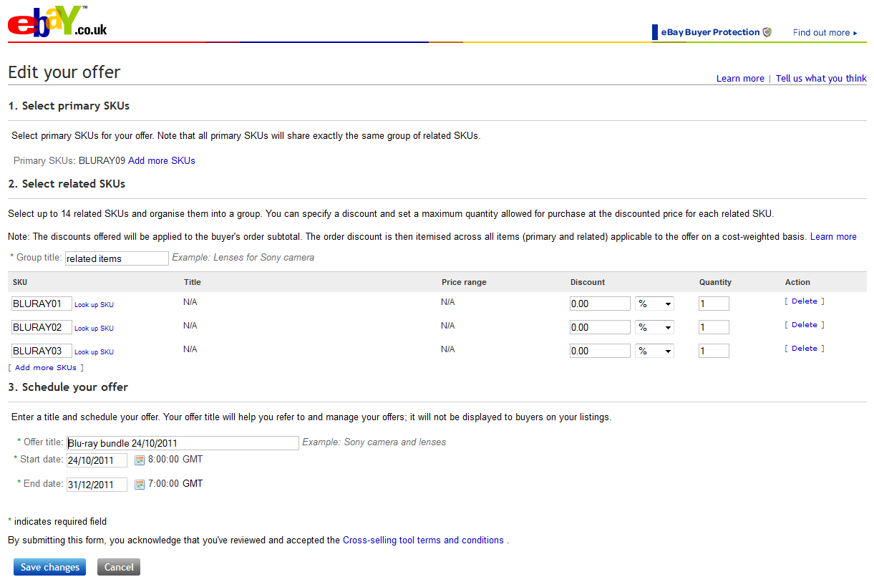  1  2  3  4

Method # 1: Web form to edit related items offers
- You may edit any field except the Start date on offers in Active or On Hold status.

- Edits you may perform are:
  - Adding or removing Primary SKUs (See figure E-1)
  - Adding or removing Related SKUs (See figure E-2)
  - Modifying the Offer title (See figure E-3)
  - Modifying the End date (See figure E-4)

Certain edits you make to an Active or On Hold offer may take up to 15 minutes to be reflected on the live eBay site.

Method # 2: Upload spreadsheet to edit related items offers
- After you click on the Bulk edit offers link from the Cross-selling tool dashboard, you will land on the Bulk edit your offers page. (See figure F)  - Click on the Go to edit your related items offers link under the “Related items offer template” option. (See figure F-1)  - You will land on the Upload/edit your related items offers page. (See figure G)  - Click on the here link to download all your existing related items offers into a .csv file. (See figure G-1)  - Open the .csv file you just downloaded and make edits directly within this spreadsheet. (See figure H)  - Remove any offers you do not plan to edit by deleting the entire row. This will make it easier for you to manage your spreadsheet.  - Do not modify the Offer ID (column A).  - Do not modify the Start date (column C) on offers in Active or On Hold status.  - Delete an entire offer from the tool by changing the Action (column E) from MODIFY to DELETE.  - Modify Status (column F) from Active to Disabled or vice versa  - Remove a single related item from an offer by deleting the cells corresponding to that item. Specifically, remove (1) Related SKU, (2) Discount type, (3) Discount value, (4) Currency code, and (5) Discount quantity limit.  - Save the file on your computer.  - Click Browse on the Upload/edit your offers page. Search for your saved spreadsheet and click Open to select the file for upload. (See figure G-2)  - Click Upload. (See figure G-3)  - Click on Cancel when you are ready to return to the dashboard.  Tip: See the Common Errors section in the Appendix for common errors and possible solutions. | Figure F  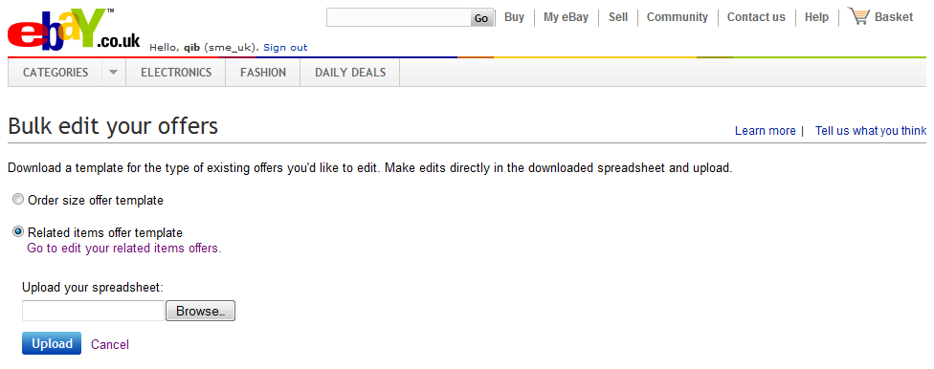  1  Figure G  1  3  2  Figure H  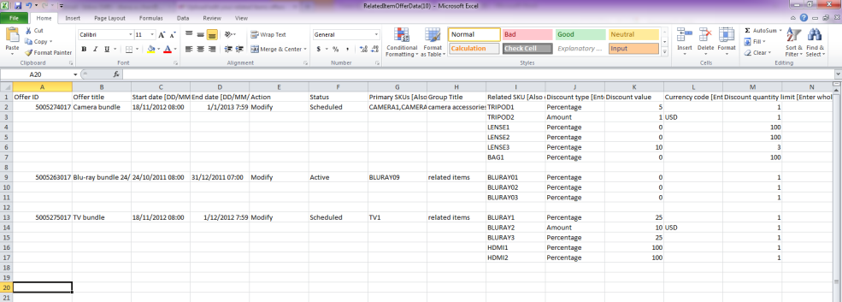
- Click on Edit from the More drop-down menu on the dashboard to edit your offer. You will be redirected to the Edit offer page. (See figure C)

- Start date cannot be changed once an offer is active.

- You can add or remove SKUs for your offer at any time.

- You can also modify, add, delete or disable your related items offers using a spreadsheet.

- Click on the Upload related items offers link from the dashboard to edit multiple offers at once.
- You will land on the Upload/edit your related items offers page.
- Download your current offers into a spreadsheet using the here link on the Upload/edit your offers page. You must make changes using this downloaded spreadsheet. (DO NOT use the saved file from your hard drive.) (See figure D)
- Delete an entire offer by changing the Action column from 'MODIFY' to 'DELETE' (see the area highlighted in red in figure E)
- You can remove a single item from an offer by deleting the cells corresponding to that item. Specifically, remove (1) Related SKU, (2) Discount type, (3) Discount value, and (4) Currency code (see the area highlighted in blue in figure E).
- Save the file on your computer.
- Click Browse on the Upload/edit your offers page. Search for your saved spreadsheet and click Open to select the file for upload.
- Click Upload.
- Click on Cancel when you are ready to return to the dashboard.

Appendix

Best practices
- Accessories: Related items sell best when they are accessories to the primary item. If you don't offer accessories, items similar to the primary product can also be used. Make sure related items are top-sellers and relevant to the primary item.
- Price of the primary item: Make the price of the primary item as competitive as possible. This helps increase sales of related items.
- Price of related items: Related items sell best when they are priced at about 20% the price of the primary item. Lower priced items are easier to sell to buyers than an additional item that is the same or higher price than the primary item.
- Discounts on related items: Buyers are more likely to purchase when discounts on related items are on average 30%. Make sure your discounts are meaningful enough to motivate buyers.
- Number of related items: Recommend at least 3 related items for every primary item.
- Experiment: Mix and match different items to see what works best. Always remember that related items must be relevant to the primary item.
- Seasonal: Promotions that match the time of year or upcoming holidays are typically well received by buyers.
- Group primary items in a related items offer: If you have the same set of related items you want to promote with multiple primary items, you can save time by creating a single offer with a list of primary items (by using add more SKUs in our web form) instead of creating an offer for each primary item. This will also make it easier for you to manage your offers at a later time.
- Microsoft Internet Explorer: If you're using Internet Explorer 7 as your web browser, we recommend that you upgrade to IE 8 or above to get the most out of Cross-selling tool's features.

Important points to note
- Buyers are not able to purchase your related items alone at the discounted price you offer as part of the related items offer. They must purchase the primary item together with one or more related items in order to get the discounted price.
- You can attach the same group of related items to 500 primary SKUs at a time through the web form, Excel bulk upload or the API. This means that each of the 500 primary SKUs will display the same set of related items. Research shows that showing accessories and relevant related items is essential to sales, so use this feature only when you genuinely have interchangeable related items.
- If you list products on other international eBay sites, you will have to configure offers on those sites separately. If you have a listing on eBay.com/.co.uk that offers worldwide delivery, buyers will only see your configured offers if they browse the respective eBay site even though your listing is also surfaced on eBay international sites.
- UK: http://cgi1.ebay.co.uk/ws/eBayISAPI.dll?ConfiguratorAccept
- US: http://cgi1.ebay.com/ws/eBayISAPI.dll?ConfiguratorAccept
- In order to enhance the relevance of cross-sold items that are displayed on the listing page, Cross-selling tool will use an algorithm based on item price, P&P cost and quantity sold to determine the order in which your configured items are displayed. If your items are new and do not have sales history on eBay, Cross-selling tool will use the order in which you provided the SKUs to determine the display position.
- The discount given as a part of your offer is calculated based on the total regular price of all eligible items prior to any other discounts, P&P costs, and other fees. For a free item with purchase offer, the undiscounted price of the lowest-priced item(s) will be applied as the discount towards the entire order.
- The discount given as a part of your offer will be applied to the entire order and distributed on a cost-weighted basis to each qualifying item purchased in the order.
Examples

Example 1: Get 50% off a camera bag (normal price £100) with the purchase of a camera (normal price: £900)

Normal undiscounted prices in the order:
Camera: £900
Bag: £100

Undiscounted subtotal: £1,000
Total discount: £50 (50% off £100)
Equivalent order discount in percentage terms: 5% (£50 off £1,000)

5% discount applied to items in the order:
Camera: £900 minus 5% = £855
Bag: £100 minus 5% = £95

Example 2: Save £10 when you spend £150 or more

Normal undiscounted prices in the order:
Trousers: £60
Shirt: £40
Coat: £100

Undiscounted subtotal: £200
Total discount: £10
Equivalent order discount in percentage terms: 5% (£10 off £200)

5% discount applied to items in the order:Trousers: £60 minus 5% = £57
Shirt: £40 minus 5% = £38
Coat: £100 minus 5% = £95

Example 3: 3 Items for the price of 2 (value of lowest-priced item(s) will be discounted from the subtotal amount)

Normal undiscounted prices in the order:
Trousers: £60
Shirt: £40
Coat: £100

Undiscounted subtotal: £200
Total discount: £40 (price of lowest price item: shirt)
Equivalent order discount in percentage terms: 20% (£40 off £200)

20% discount applied to items in the order: Trousers: £60 minus 20% = £48
Shirt: £40 minus 20% = £32
Coat: £100 minus 20% = £80

Example 3a: 3 items for the price of 2 (value of lowest-priced item(s) will be discounted from the subtotal amount)

Normal undiscounted prices in the order:
Trousers: £60
Shirt: £40
Coat: £100
Suit: £200

Undiscounted subtotal: £400
Total discount: £40 (Price of lowest price item: shirt)
Equivalent percentage order discount: 10% (£40 off £400)

10% discount applied to items in the order: Trousers: £60 minus 10% = £54
Shirt: £40 minus 10% = £36
Coat: £100 minus 10% = £90
Suit: £200 minus 10% = £180

- If the buyer exercises his right to cancel his order from a Business Seller and return one or more of the items in a Special Offer, the seller shall refund the buyer at least the weighted discounted value of the item being returned. For items purchased as part of a Special Offer, the returns policy specified in each individual listing will apply to the return of each respective item. If a seller’s return policy for an item permits returns, the item price that the seller reimburses the buyer must at a minimum be the cost-weighted discounted price of the returned item as displayed in My eBay. For example, a buyer purchases a TV for £900 and adds a £100 Blu-ray player to his order to get a £50 discount as a part of your related items offer; £45 discount was applied to the TV and £5 discount was applied to the Blu-ray player. If the buyer returns the TV, but keeps the Blu-ray player, you should refund him £900-£45 = £855.
- If you use Markdown Manager, the discounts you configure for related items offers and order size offers will be on top of the marked down prices.
- If you've configured combined postage promotions in My eBay, they will continue to work as usual in checkout.
- All individual items sold with a cross-selling offer that have the same delivery service will be grouped together as a single order in order details. You will continue to have the ability to provide one tracking number for all items in an order or provide different tracking numbers for individual item(s) in an order.
- Cross-selling offers shown on listing pages will not be double counted towards your listing page views or impressions. As your sales increase from your offers, your page view or impression to sales ratio will also improve.
- There's no 'silver bullet' for getting a good position in search. Participation in Cross-selling tool will not directly give you an advantage in your listings' search results rank; however, sales of all items with a cross-selling offer will count as a sale for each item's listing. As a result, the listing will automatically move up in rank in Best Match over time as sale is taken into account in the Best Match algorithm.

Common errors
Here are some common errors encountered when uploading Excel files (and possible solutions):
- 'Discount price is more than the item price' - Make sure the item price of the related SKUs is more than the discount amount. For example, you cannot apply a £7 discount to a £5 item.
- 'Related items count exceeded maximum allowed limit' - The maximum number of related SKUs in a related items offer is 14. Remove the extra SKUs to resolve the error.
- 'Primary SKU same as related SKU' - Related SKUs in a related items offer cannot be identical to the primary SKU in the same offer.
- 'Cannot enter more than 25 SKUs' - The maximum number of SKUs in an order size offer is 25. Remove the extra SKUs to resolve the error.
- Make sure you don't create multiple related items offers with the same primary SKU.
- If you modify your listings on eBay to meet the minimum requirements for a Cross-selling tool offer (such as adding a SKU or custom label to a listing or changing a related item to offer free P&P), it could take up to 4 hours for the modified listing to show up on the listing page as a part of an offer.
  - Upload no more than 1,000 related items offers in one spreadsheet.
- Upload no more than 500 order size offers in one spreadsheet.

Helpful links
- Cross-selling tool: UK | US
- Selling Manager and Selling Manager Pro: UK | US
- Turbo Lister: UK | US
- Bulk edit and revise in My eBay: UK | US
- File Exchange: UK | US
- eBay Category ID Lookup: UK | US

